**Umpquapedia and Taxonomy Plan for Umpqua Bank**

# Current ‘As Is’ State

The current state of the Umpqua Bank Insider is ad hoc representation of the banks internal communications state. Rebuilding the taxonomy of both Umpquapedia and The Insider is the basis for improved efficiency of navigation and SEO capabilities.

Figure 1: Insider Taxonomy As Is

Insider Site Collection

Site Collection

News

Departments

Employee Directories

Campaigns

Etc

While this configuration functions as a basic operational site collection, if fails to take advantage of the extended capabilities provided by a more advanced taxonomy.

For example there are already certain Site Collections which have been forced into their own taxonomies by size and/or special needs: Legal, Project Management and TAG. These show that the ‘one size fits all’ model is already unable to fil the needs of the Umpqua Bank SharePoint community.

Umpaquapedia is also presented in a basic form with some of the most active parts represented as Libraries

Figure 2: Umpqapedia As Is

Umpquapedia

Compliance

Product Guide

Survey

Forms

Libraries:

Corporate Policies

Rates & Fees

Photo Gallery

Documents Department

# ‘To Be’ State

The ’To Be’ state is to have all entities within Umpqua Bank migrate to the SharePoint environment in order to take advantage of the efficiencies provided, not least of which are improved taxonomic organizational and data repository relationships and targeted search capabilities. Where this is possible, t is preferred especially in the context of overall data security.

Figure 3: Insider To Be

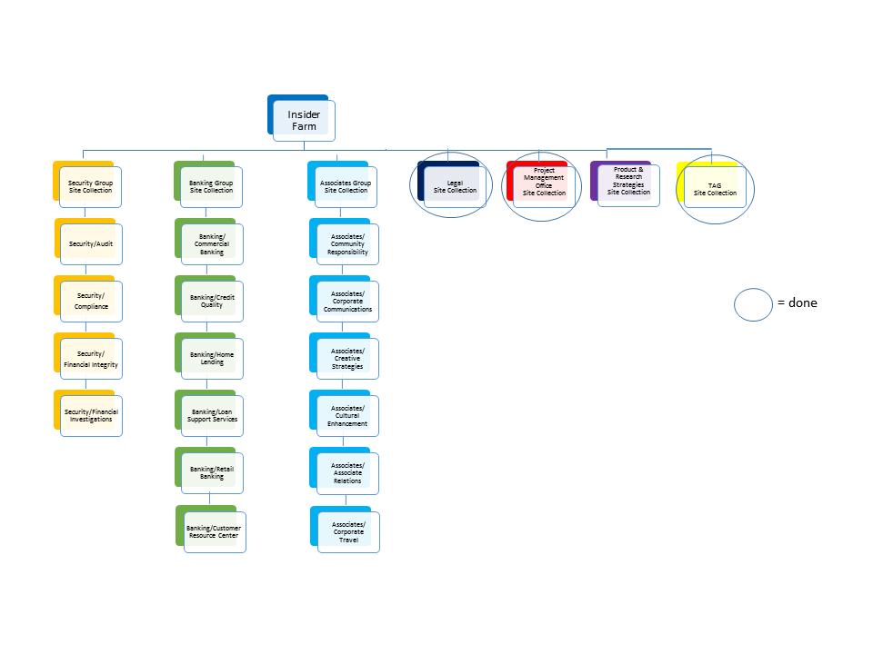

Top row are new  
Site Collections

Similarly Umpqaupedia will have a new structure:

Figure 4: Insider To Be

Umpquapedia

Compliance

Forms

Product Guide

Survey

Corporate Policies

Rates & Fees

Photo Gallery

Document department

# Milestones and Completion Dates

The timeline shown below represents the best guess that can be made at this point based on past experience. I have built in some extra overhead to make sure that milestones are reached in good time. I expect that, as the work progresses, I can leverage acquired results and data to accelerate the overall process.

Goals of the Taxonomy and SEO changes:

* Provide separated taxonomy so specialized functionality can be enhanced in each publishing Site Collection
* Provide cross-site publishing for coordinated efforts
* Institute and monitor CMS requirements in order to build a searchable, auditable database of documents going forward
* Provide targeted SEO operations containing Content Typing and specific Term Sets appropriate to the Site Collection

I would recommend that we work in a development environment which can accommodate as many helpful agents as necessary. Most of the development work can be done by personnel attached to the project with occasional outside help regarding scripting and integration with already extant capabilities. Progress can be reviewed and tested (some use of testing resources will be required) without affecting the live dev/test/prod process. When appropriate, a more general review will be established to decide when and how to integrate the new environment into the production stream.

Figure 2: Timeline Milestones and Scheduling



# Using the Advantages of Taxonomic Capabilities

Each of these business entities has general search access needs and needs access to a focused set of information. Using the methodology outlined above will allow us to create specific search supersets for the business units. In addition, there will be overlapping term sets and reusable content types and term sets. This means that there will be individual and integration efficiencies for enterprise search and site specific search as this taxonomy pan goes forward.

## Taxonomy by Department

Associate Relations  
Audit  
Commercial Banking  
Community Responsibility  
Compliance  
Corporate Communications  
Corporate Travel  
Creative Strategies  
Credit Quality  
Cultural Enhancement  
Financial Integrity  
Financial Investigations  
Home Lending  
Loan Support Services  
Product and Research Strategies  
Project Management Office  
Retail Banking

Breaking these out by associative groups (in terms of search requirements), we have:

**Security Group**

Audit  
Compliance  
Financial Integrity  
Financial Investigations

**Banking Group**

Commercial Banking  
Credit Quality  
Home Lending  
Loan Support Services   
Retail Banking  
Product and Research Strategies

**Associates Group**

Community Responsibility  
Corporate Communications  
Creative Strategies  
Cultural Enhancement   
Corporate Travel  
Associates Relations

**Singleton Entities**

Legal

Project Management Office

Project Research

TAG

Umpquapedia

That is five groups with identifiable custom search requirements. Custom solutions, i.e. Term Sets must be developed for these Site Collections as they have particular needs which will be useless for the other Site Collections.

## Umpquapedia and CMS

CMS features available (document management, collaboration, search, workflows, Business Intelligence, etc.) will advance and enhance the utility and efficiency of Umpquapedia, especially as regards ongoing document management and security of records.

Regards,

Craig Della Penna

Appendix A

The following table displays the pros and cons of each column type.

|  |  |  |  |
| --- | --- | --- | --- |
| **Column Type** | **Pros** | **Cons** | **Conclusion** |
| Choice Column | Self-contained, not affected by changes elsewhere  Can have a default value set in list/library settings  Selectable within Quickparts added to Word documents, even in older Word versions  Can be used as values in calculated columns.  Easiest to use in SharePoint Designer workflows.  Easy to manipulate programmatically | Updating one of the values does not force that change on all items tagged with the value; you need to make manual changes to each item to correct.  There is no way to constrain deletion of values in use.  User must have rights sufficient to change list settings to update the column (in certain circumstances, this could be a 'pro')  By default, choice columns are not automatically promoted to search refiners; manual steps requiring a high level of user rights must be completed to enable this  Using OOB SharePoint UI, cannot remove a value from tagging options going forward without deleting the value from the choices.  Data cannot easily be pulled in from external sources to populate choice column  Choice columns do not support hierarchical relationships  Values cannot be merged  Cannot add synonyms  No autosuggest feature | Choice columns should be used for local (list level) columns that will not change frequently or for site columns that have no search refiner value.  Choice columns should not be used for lists that are likely to get very large unless it is extremely unlikely that the values will ever change.  Regardless of the above, you may need to use a choice column if your requirements call for the field to be evaluated or manipulated in a calculated column. |
| Lookup Column | Easy for end users with contribute rights to maintain.  Can constrain deletion of values in use  Data can be pulled in from external sources fairly easily  Updating a value in the lookup list forces the chance down to all items that are tagged with that value  Easy to use in SharePoint designer workflows. | Default value cannot be set at the list/library level.  Cannot be selected within Quickparts in some older Word versions.  More complicated to manipulate programmatically than choice values  Using OOB SharePoint UI, cannot remove a value from tagging options going forward without deleting the value from the lookup list  By default, lookup columns are not automatically promoted to search refiners; manual steps requiring a high level of user rights must be completed to enable this  You must be careful to place your lookup list at the correct level in the site collection so that all sites needing to use the data in site columns can inherit it.  If you wish to make your lookup available across site collections, you must create it in the content type hub, which requires special rights to access  Lookup columns do not support hierarchical relationships  Lookup column values cannot be used in calculated columns  Values cannot be merged  Cannot add synonyms  No autosuggest feature | Lookup Columns are the best choice if you have master data in another location (such as a SQL database) and want to use it as metadata in SharePoint.  Lookup columns are also an excellent choice in environments where you don't have the support, time, or budget to undertake an organization-wide taxonomy effort but you want to standardize at the site collection level.  Lookup columns at the site level that users can add to are a great way to see how they categorize their information and can be used later as the starting point for a formal taxonomy via the term store.  If you need to use a lookup column value in a calculation, you will probably need a workflow to meet your requirements. |
| Managed Metadata Column | Supports hierarchical relationships and rollups  Changes in a value are pushed down everywhere the tag is used  Can add synonyms that are used in search and when tagging  Individual terms can be hidden from tagging interfaces if they are no longer in use  Automatically promoted to search refiners  Default value can be set at the list/library level  Automatically suggests terms as the user types based on input  Hierarchy is flexible and can be changed without breaking connections to tagged items | Do not display easily in emails produced by SharePoint designer.  Hardest to manipulate programmatically.  More difficult to populate based on external data.  Managed metadata values cannot be used in calculated columns.  Cannot be selected in Quickparts in older Word versions  Requires careful planning and centralized curation by trained staff familiar with the business processes of the entire organization. | Managed metadata columns based on the SharePoint term store are the hands-down choice for managing organizational taxonomy and tagging, especially across site collections.   In addition, Managed Metadata columns provide the best OOB search experience.  If you need to use Managed Metadata columns in calculations, plan to spend some time and effort on workflows and other workarounds.  Likewise, you will need custom solutions to pull data from other databases into the term store. |